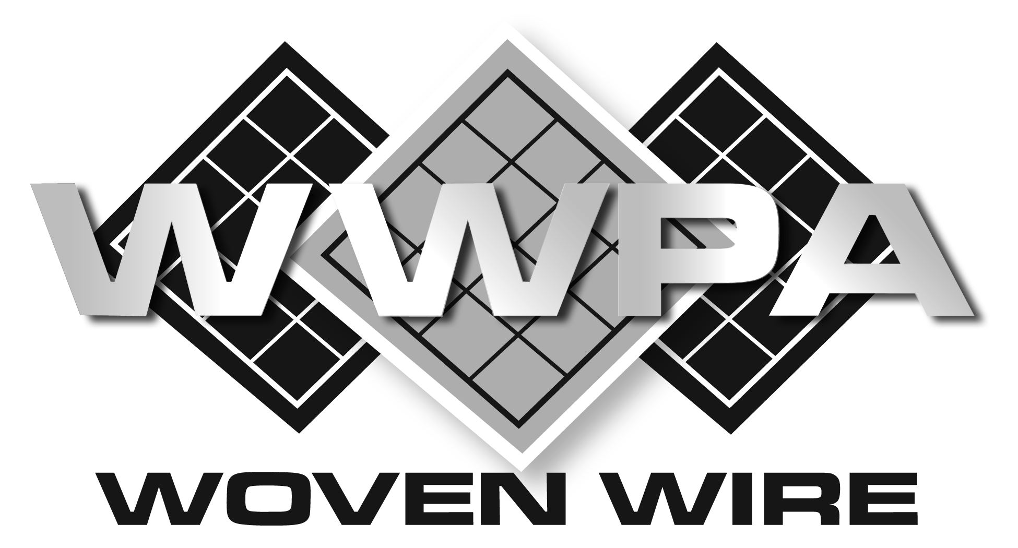

SECTION 10 22 13

HEAVY DUTY WIRE MESH WINDOW GUARDS

** NOTE TO SPECIFIER ** heavy duty woven wire mesh partitions, wire mesh infill panels, window guards, and area guarding.
.
This section is based on the products manufactured by active members of the Woven Wire Products Association. For more information, please contact:

Woven Wire Products Association
P.O. Box 424
ATTN: Kimberly Adkins, Executive Secretary
Mason, Ohio 45040
Email: info@wovenwire.org
Web: www.wovenwire.org
The Woven Wire Products Association (WWPA) was established in 1942 as a professional association representing U.S. manufacturers of diamond woven wire mesh products. WWPA members emphasize high quality workmanship and ethical business standards, and produce woven wire products for institutional, industrial, and architectural applications.
With over 1,000 years of combined experience, WWPA member companies are the preeminent manufacturers of woven wire partitions, window guarding, and railing infill panels. Architects and general contractors have trusted the WWPA over the years to deliver high quality products, along with exact specifications to match the needs of their active projects.
.
- GENERAL
  - SUMMARY
    - Heavy-Duty Wire Mesh Window Guards
  - RELATED DOCUMENTS
** NOTE TO SPECIFIER ** Delete any sections below not relevant to this project; add others as required.
    - Drawings and general provisions of the Contract, including General and Supplementary Conditions and Division 01 Specification Sections, apply to this Section.
    - Section 03300 - Cast-In-Place Concrete: Restriction on location and penetration depth of fasteners.
  - SUBMITTALS
    - Submit under provisions of Section 01 30 00.
    - Product Data: Manufacturer's data sheets on each product to be used, including:
      - Detailed specification of construction and fabrication.
      - Manufacturer's installation instructions.
      - Preparation instructions and recommendations.
      - Storage and handling requirements and recommendations.
    - Shop Drawings: Indicate dimensions, description of materials and finishes, general construction, specific modifications, component connections, anchorage methods, hardware, and installation procedures, plus the following specific requirements.
      - Provide location template drawings for items supported or anchored to permanent construction.

** NOTE TO SPECIFIER ** Delete selection samples if colors have already been selected.
    - Selection Samples: For each finish product specified, two complete sets of color chips representing manufacturer's full range of available colors and patterns.
  - QUALITY ASSURANCE
    - Installer Qualifications
      - Construct areas designated by Architect.
      - Do not proceed with remaining work until workmanship, color, and sheen are approved by Architect.
      - Repair and correct mock-up area as required to produce acceptable work.
    - Design Requirements:
      - Design window guards to provide for movement of components without damage, undue stress on fasteners or other detrimental effects, when subject to design loads.
      - Design system to accommodate construction tolerances, deflection of building structural members, and clearances of intended openings.
    - Source Limitations: Obtain wire mesh items for single source from single manufacturer.
  - DELIVERY, STORAGE, AND HANDLING
    - Store products in manufacturer's unopened packaging until ready for installation.
** NOTE TO SPECIFIER ** Delete items below not required for project. Wrapping and packaging as detailed below may require additional costs.
      - Materials may ship uncrated per Manufacturer’s recommendation in order to maximize volume on common carrier and to reduce freight cost.
      - Materials to be crated or palletized with cardboard protectors on perimeters of panels and doors and strapped using nylon materials within crating. Crates are non-returnable and the responsibility of the customer for proper disposal.
    - Store products in manufacturer’s unopened packaging until ready for installation.
  - PROJECT CONDITIONS
    - Field Measurements: Customer to verify actual dimensions of construction contiguous with wire mesh units by field measurement before fabrication.
    - Maintain environmental conditions (temperature, humidity, and ventilation) within limits recommended by manufacturer for optimum results. Do not install products under environmental conditions outside manufacturer's absolute limits.
- PRODUCTS
  - MANUFACTURERS
    - Acceptable Manufacturers: Active members, in good standing, with the Woven Wire Products Association (WWPA), www.wovenwire.org:
** NOTE TO SPECIFIER ** We suggest you verify the member is still in good standing to be considered for solicitation by reviewing our active member list at www.wovenwire.org
      - Apex Iron Works
      - G-S Company, The
      - Indiana Wire Products
      - Kenco Wire & Iron Products, Inc.
      - Miller Wire Works, Inc.
      - Newark Wire Works, Inc.
      - Robert J. Donaldson Co., Inc.
      - SpaceGuard Products, Inc.
      - Standard Wire & Steel Works
      - Wire & Iron Products (WIPCO), a Division of Jesco Industries, Inc.
    - Substitutions: Not permitted if only considering materials certified by the Woven Wire Products Association
  - MATERIALS
    - Steel Wire: ASTM A 510 (ASTM A 510M).
    - Steel Plates, Channels, Angles, and Bars: ASTM A 36/A 36M.
    - Cold-Rolled Steel Sheet: ASTM A 1008/A 1008M, Commercial Steel (CS), Type B.
    - Square Steel Tubing: ASTM A 500, cold-formed structural steel tubing.
    - Panel-to-Panel Fasteners: Manufacturer’s standard steel bolts, nuts, and washers.
    - Postinstalled Expansion Anchors: With capability to sustain, without failure, load imposed within factors of safety indicated, as determined by testing per ASTM E 488, conducted by a qualified independent testing agency.
      - Carbon steel: Zinc plated to comply with ASTM B 633, Class Fe/Zn 5 (0.005 mm) for Class SC 1 service condition (mild)
      - For Postinstalled Anchors in Concrete: Capability to sustain, without failure, a load equal to four times the loads imposed.
  - PRODUCT
    - Mesh: No. 6 gauge, steel wire triple crimped and woven into 2 inch diamond or 2 inch square mesh pattern.
    - Horizontal Frames: 1-1/2 inch by 3/4 inch - 11 gauge or thicker steel channel.
    - Vertical Frames: 1-1/2 inch by 3/4 inch - 11 gauge or thicker roll formed "C" type steel channels. Series of slotted holes for securing to adjacent panels and post.
    - Horizontal Reinforcement Members: Two 1 inch by 1/2 inch or greater - 11 gauge or thicker steel channel toe riveted or bolted together through mesh and welded to vertical frames.
    - Panels: Single panels are made up to 60 inches wide and 144 inches high. Consisting of the above horizontal and vertical members mortised and tenoned at corners with diamond mesh securely attached to frames. Center reinforcement bars attached, as noted.
    - Jambs: Minimum 1-1/4 inch by 1-1/4 inch by 1/8 inch angle with minimum 5/16 inch bolt holes for anchorage at a minimum spacing of 24 inch centers
Panels: Single panels are made in any width up to 60 inches and heights up to 144 inches. Consisting of the above horizontal and vertical members mortised and tenoned at corners with diamond mesh securely attached to frames. Lower horizontal member is located no more than 3-3/4 inch from bottom of panel to create maintenance sweep space. Horizontal reinforcement bars attached, as noted. ** NOTE TO SPECIFIER ** Delete Guard Types not required
    - Fixed Type
    - Lift-Out Type: Pin, hasp and staple type; or, cradled angle also acceptable
    - Hinge-Type Guards: Provide emergency exit devices per code based upon customer security and exiting requirements
Panels: Single panels are made in any width up to 60 inches and heights up to 144 inches. Consisting of the above horizontal and vertical members mortised and tenoned at corners with diamond mesh securely attached to frames. Lower horizontal member is located no more than 3-3/4 inch from bottom of panel to create maintenance sweep space. Horizontal reinforcement bars attached, as noted. ** NOTE TO SPECIFIER ** Remove options not required
      - Hinges: Minimum of one pair of 3 inch by 3 inch or greater butt hinges with non-removable pin and heavy duty barrel bolt.
      - Padlock Arrangement: Lug(s) to be welded, through bolted, or riveted securely to system.
      - Hook Bar Locking Device: Welded to system
    - Finish:
** NOTE TO SPECIFIER ** Delete all except the required finish.
      - Powder coated in manufacturer’s standard gray or black.
      - Powder coated in color as selected by Architect from manufacturer’s standard color chart.
      - Sprayed enamel in manufacturer’s standard gray or black.
      - Sprayed enamel in color as selected by Architect from manufacturer’s standard color chart.
      - Hot-Dipped Galvanized

  - FABRICATION
    - Fabricate assemblies of framed sections; to sizes and profiles required; with framing members fitted, reinforced and braced to suit design requirements.
    - Fit and assemble in largest practical sections for delivery to Project Site, ready for installation.
    - Fabricate items with joints tightly fitted and secured.
    - Grind exposed welds smooth and flush with adjacent finish surface. Ease exposed edges to small uniform radius.
    - Make exposed joints flush and hairline.
    - Provide components required for anchorage. Fabricate anchorage and related components of same material and finish as framing members.
  - FINISH
    - Clean surfaces of rust, scale, grease, and foreign matter before finishing. Clean material using a two to three stage wash system immediately prior to finishing.
    - Prefinished Surfaces: Material to be prime coated if required prior to finishing.

- EXECUTION
  - EXAMINATION
    - Verification of Conditions: Examine areas and conditions under which Work is to be performed and identify conditions detrimental to proper or timely completion.
      - Do not proceed until unsatisfactory conditions have been corrected.
  - INSTALLATION
    - Comply with manufacturer's recommendations.
    - Install partitions and gates plumb and level, accurately fitted, properly aligned, securely fastened, and free from distortion or detects.
  - TOLERANCES
    - Maximum Variation from Plumb or Level: 1/4 inch (6 mm.
    - Maximum Misalignment from True Position: 1/4 inch (6 mm).
  - ADJUSTING
    - Adjust moving components for smooth operation without binding.
    - Adjust locks to provide smooth and secure operation.
  - PROTECTION
    - Protect installed products until completion of project.
    - Touch-up, repair or replace damaged products before Substantial Completion.

END OF SECTION

